SYTR GOVT DEGREE COLLEGE

MADAKASIRA

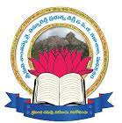

**DEPARTMENT OF ENGLISH**

**ACADEMIC YEAR – 2021-22**

**CONDUCTING REMEDIAL CLASSES FOR 2 YEAR B.A & B. Sc STUDENTS**

**CONDUCTING CLASSES ON FUNCTIONAL ENGLISH**

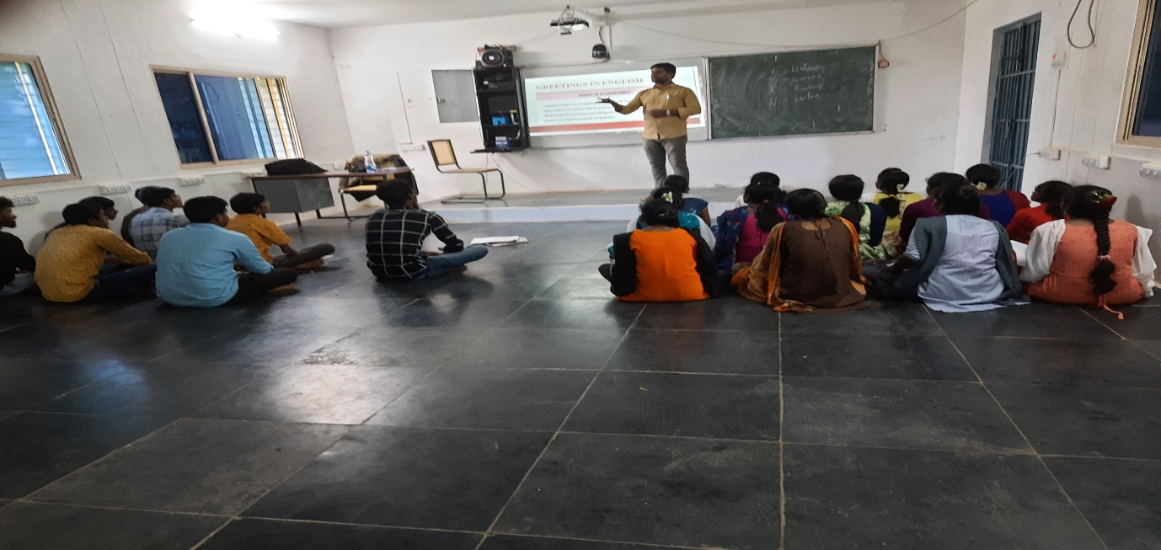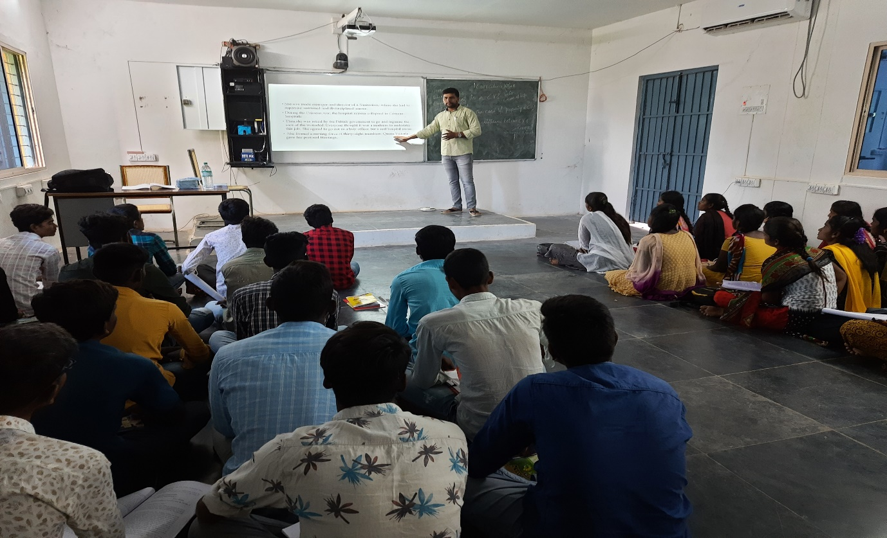

Engaging remedial classes for II B.A Students

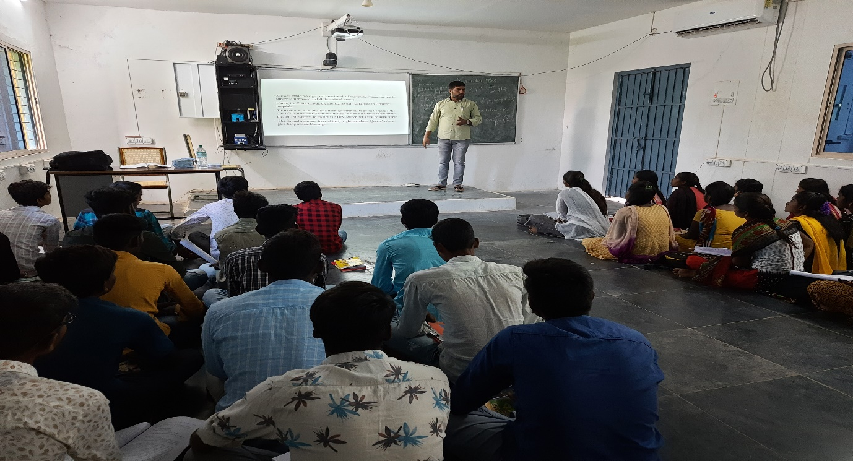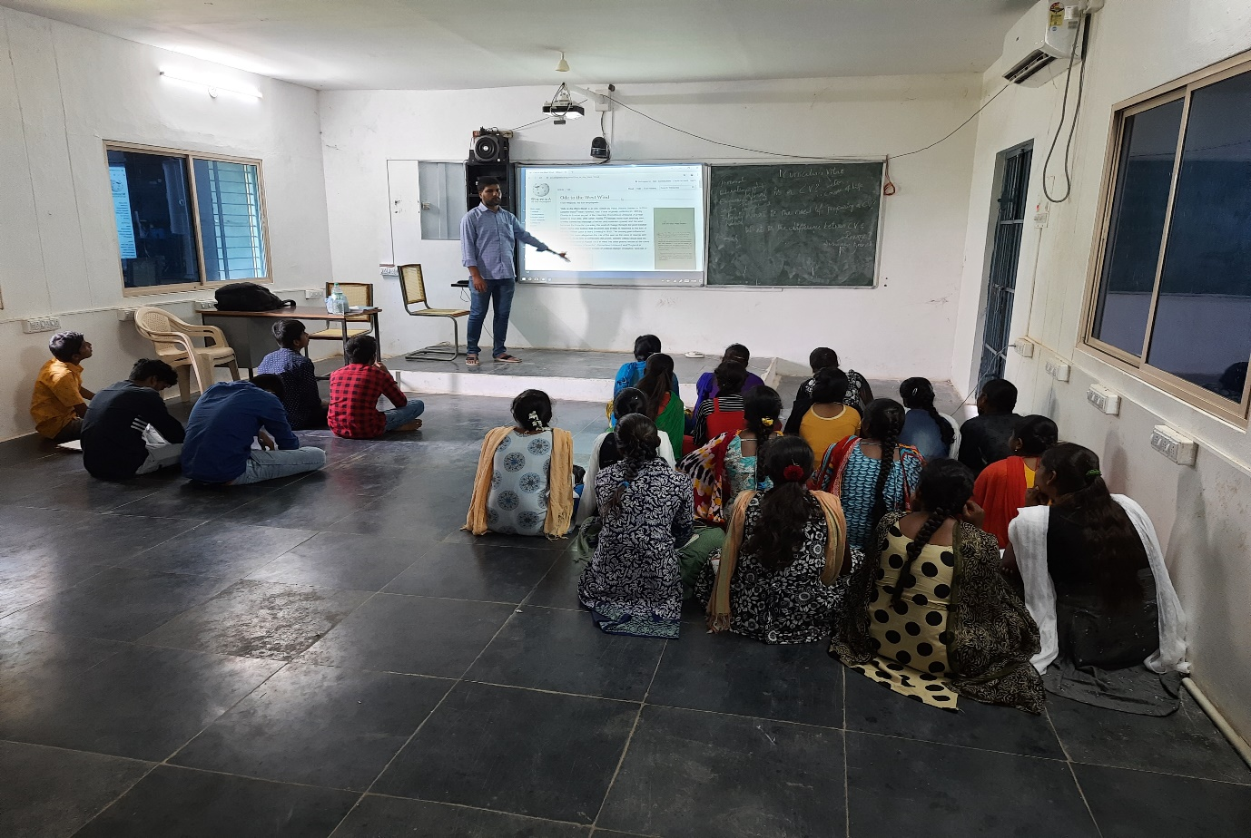

**Engaging remedial classes for II B. Sc students**

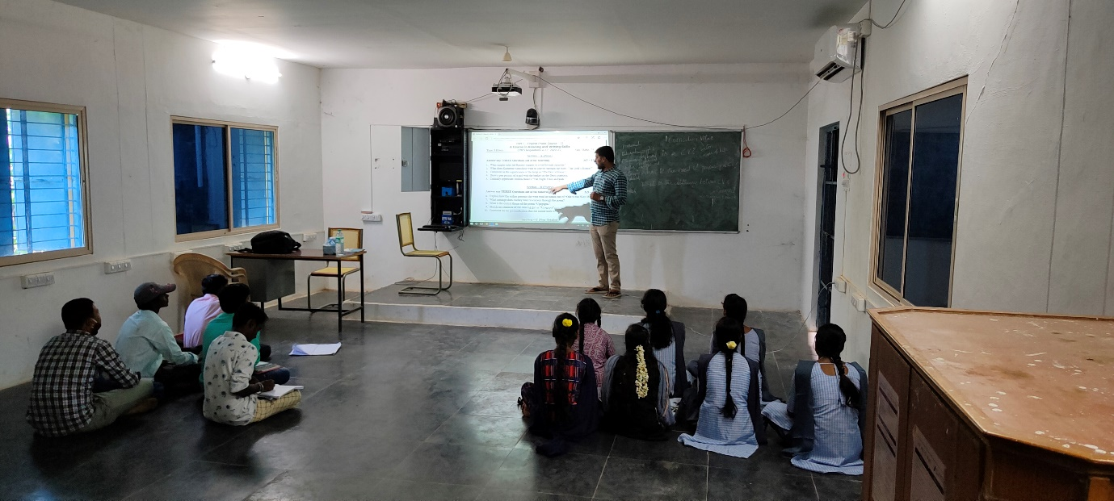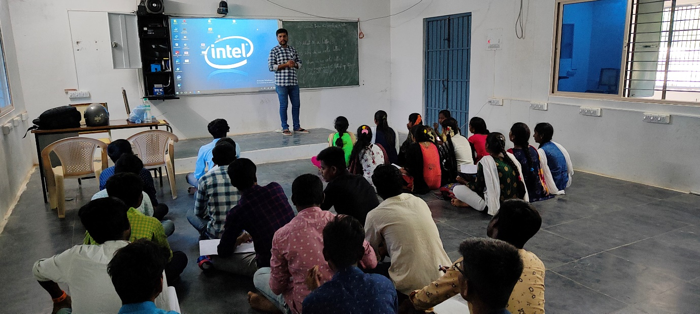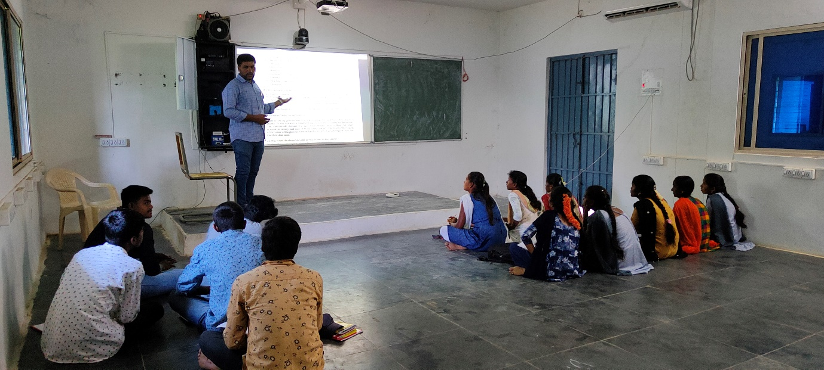

**REMEDIAL CLASSES ON COMPREHENSION PASSAGES**

SYTR GOVT DEGREE COLLEGE

MADAKASIRA



**DEPARTMENT OF ENGLISH**

**ACADEMIC YEAR – 2022-23**

**Engaging Remedial Classes to Second Year Students**

